

**Test 5 2015**

**Bonding II and Chromatography**

**Acids and Bases**

**Question/Answer Booklet**

**CHEMISTRY**

**Stage 2**

|  |  |
| --- | --- |
| **Student Name:** |  |

|  |  |
| --- | --- |
| **Section** | **Mark** |
| One | /16 |
| Two | /34 |
| Total | /50 |
| % | |

**Time allowed for this paper**

Working time for paper: 45 minutes

**Material required/recommended for this paper**

***To be provided by the supervisor***

This Question/Answer booklet

Chemistry Data sheet

***To be provided by the candidate***

Standard items: pens (blue/black preferred), pencils (including coloured), sharpener, correction fluid/tape, eraser, ruler, highlighters

Special items: non-programmable calculators approved for use in the WACE examinations

**Important note to candidates**

No other items may be taken into the examination room. It is **your** responsibility to ensure that you do not have any unauthorised notes or other items of a non-personal nature in the examination room. If you have any unauthorised material with you, hand it to the supervisor **before** reading any further.

**Section One: Multiple-choice (16 marks)**

This section has **8** questions. Answer **all** questions on the grid below

Each question has only one correct answer. Select your answer by placing a cross in the box on the answering grid below. Attempt all questions.

**Please mark the correct answer with an ‘x’ on the answer grid below.**

|  |  |  |  |  |
| --- | --- | --- | --- | --- |
| **Question** |  |  |  |  |
| **1** | A | B | C | D |
| **2** | A | B | C | D |
| **3** | A | B | C | D |
| **4** | A | B | C | D |
| **5** | A | B | C | D |
| **6** | A | B | C | D |
| **7** | A | B | C | D |
| **8** | A | B | C | D |

1. Two solutions of equal concentration, A and B, have a pH of 3 and 6 respectively. Which of the following statements about the solutions is/are true?
2. They will show the same colour in universal indicator.
3. The concentration of H+ is higher in B than it is in A.
4. B is a weaker acid than A.
5. (ii) only
6. (iii) only
7. (i) and (ii) only
8. (i), and (iii) only

2. The following questions relate to this equation:

HPO42-(aq) + H2O(l)  H2PO4-(aq) + OH-(aq)

Which of the following statements is **false?**

a) The HPO42- behaves as a base.

b) The water is acting as an acid..

c) The H2PO4- is acting as an acid.

d) The hydroxide ion is acting as a conjugate acid

3. Which of the following groups is ranked in order of increasing molecular polarity?

a) CH2Cl2, CH2F2, CH2I2

b) H2Te, H2Se, H2S

c) HBr, HF, HI

d) CH3F, CH4, CF4

4. Which one of the following could be true in an aqueous solution of sodium hydroxide?

1. [H+] = (OH-]
2. pH = –log10 [OH-]
3. pH= 1.2
4. pH = 12.8

5. Which one of the following is the change in units of pH which occurs when 10.0mL of a 1.0 M solution of a strong monoprotic acid are made up to 1.0 L with water?

1. 1
2. 2
3. 3
4. 5

6. 10.0 mL of water is added to one litre (1L) of pure ethanoic acid. The resulting

solution is:

a) A dilute solution of a weak acid

b) A concentrated solution of a weak acid

c) A dilute solution of a strong acid

d) A concentrated solution of a strong acid

7. Reverse phase high pressure liquid chromatography uses a non-polar stationary phase and a polar mobile phase. Which of the following would have the longest retention time on the reverse phase column?

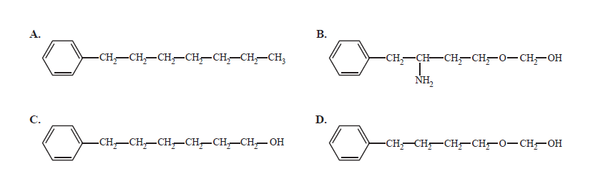8. The diagram below shows the chromatogram for large straight chain alkanes (hydrocarbons containing only carbons and hydrogens).

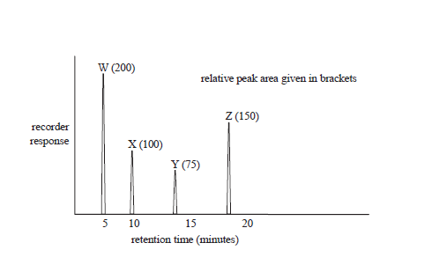

The following statements refer to the chromatogram.

I. The boiling points are arranged in increasing boiling point W> X>Y> Z.

II. The retention times will remain the same if the temperature at which the chromatogram is recorded is increased, all other conditions remaining constant.

III. Hydrogen gas could have been used as a carrier gas to obtain this chromatogram.

Which of the above statements are true?

a) I only

b) I and II only

c) I and III only

d) II and III only

**END OF SECTION ONE**

Section 2: Extended Answers (34 MARKS)

Question 1

a) Using an equation, define pH: (1)

…………………………………………………………………………………………...

b) 100.0 L of a 0.010 mol L-1 solution of hydrochloric acid is concentrated by careful evaporation of the water to a final volume of 10.0 L. Calculate the final pH of the solution. Be sure to show all working. (2)

…………………………………………………………………………………………...

…………………………………………………………………………………………...

…………………………………………………………………………………………...

Question 2

Write balanced equations (ionic where appropriate) to represent the following reactions: (9)

a) Lead (II) oxide solid and dilute nitric acid are mixed

Observation: ………………………………………………………………………………….

Equation: ……………………………………………………………………………………..

…………………………………………………………………………………………………

b) A piece of magnesium carbonate is reacted with dilute hydrochloric acid.

Observation: ………………………………………………………………………………….

Equation: ……………………………………………………………………………………..

…………………………………………………………………………………………………

c) Some small pieces of calcium are added to dilute phosphoric acid

Observation: ………………………………………………………………………….

Equation: ……………………………………………………………………………..

1. …………………………………………………………………………………………

Question 3 (6 marks)

For each species listed in the table below show the bond diagram ***showing the shape*** or molecular geometry. No marks will be given for the electron dot diagram but may aid in your structural diagram. For each identify the species as polar or non-polar.

|  |  |  |  |
| --- | --- | --- | --- |
| **Species** | **Electron dot diagram** | **Structure Diagram (1 mark each)** | **Polar or Non-polar (1 mark each)** |
| Phosphate ion  (PO43-) |  |  |  |
| Phosphine  (PH3) |  |  |  |
| Thionyl chloride  SOCl2 |  |  |  |

Question 4 (4 marks)

For each of the solid substances state the two most important types of bonding acting within that substance. The first one has been done for you.

|  |  |
| --- | --- |
| **Substance** | **Two strongest bonding forces** |
| Oxygen (O2) | Covalent: dispersion |
| Hydrogen chloride |  |
| Sodium hydroxide |  |
| Water |  |
| Graphite |  |

Question 5 (4 marks)

With reference to strength and types of intermolecular forces account for the difference in the boiling points of the following pairs of compounds.

a. methanol (65 ⁰C) and methane, CH4 ( -162 ⁰C) (2 marks)

____________________________________________________________________________________________________________________________________________________________________________________________________________________________________________________________________________

b. methanol (65 ⁰C) and octane, C8H18 (126 ⁰C) (2 marks)

____________________________________________________________________________________________________________________________________________________________________________________________________________________________________________________________________________

Question 6 (4 marks)

Consider the following situations and suggest the BEST chromatographic technique. You must use each at least once. Briefly state a reason for your choice.

Gas chromatography

High Pressure Liquid Chromatography

Thin Layer Chromatography

a. A technique suitable for analysing minute samples of volatile fuel residues extracted from the burnt remains at a suspected arson scene. ______________________________________________________________________________________________________________________________________

b. A pharmacological analysis of a mixture of a very high molar mass proteins and polypeptides present in biological fluids.

______________________________________________________________________________________________________________________________________

c. Analysis of air sample for pollutants like sulphur dioxide, nitrogen oxides and various hydrocarbon compounds.

______________________________________________________________________________________________________________________________________

d. Analysis of the sugar content of a fruit juice.

______________________________________________________________________________________________________________________________________

Question 7 (4 marks)

A 2.89 g sample of sandstone, containing only calcium carbonate and silicon dioxide, is analysed by reacting it with hydrochloric acid.

A volume of 10.7 ml of 2.50 mol L-1 hydrochloric acid solution is required for complete reaction.

a) Write an ionic equation for the reaction (1)

______________________________________________________________________________________________________________________________________

b) Calculate the mass of calcium carbonate that is used up in the reaction. (3)

__________________________________________________________________________________________________________________________________________________________________________________________________________________________________________________________________________________________________________________________________________________________________________________________________________________

**END OF TEST**